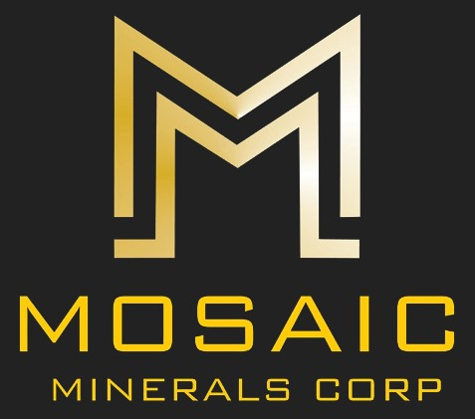

NEWS RELEASE CSE: MOC
MOSAIC ANNOUNCES WARRANT EXTENSION
February 3, 2023 – Montreal, Quebec – Mosaic Minerals Corporation (CSE: MOC) (“Mosaic” or “The Company”). The Company proposes to amend the expiry date (the “Extension”) of 3,575,00 outstanding share purchase warrants (the "Warrants") that were issued pursuant to a private placement completed in February 2021. Each Warrant currently entitles the holder to purchase one common share in the capital of the Company at a price of $0.15 per share at any time prior to 5:00 p.m. (Montreal Time) on February 23, 2023 (the “Expiry Date”). Subject to Canadian Securities Exchange approval, the Expiry Date of the Warrants will be extended to February 23, 2024. All other terms of the Warrants will remain the same.
About Mosaic Minerals Corporation
Mosaic Minerals Corp. is a Canadian mineral exploration company listed on the Canadian Securities Exchange (CSE: MOC) focusing on the exploration for future strategic Nickel and Lithium deposits. Mosaic owns more than 40,000 hectares of mining claims in the Province of Quebec. For more information, visit www.mosaicminerals.ca
M. Jonathan Hamel
President & CEO
jhamel@mosaicminerals.ca
This release contains certain “forward-looking information” under applicable Canadian securities laws concerning the Arrangement. Forward-looking information reflects the Company’s current internal expectations or beliefs and is based on information currently available to the Company. In some cases, forward-looking information can be identified by terminology such as “may”, “will”, “should”, “expect”, “intend”, “plan”, “anticipate”, “believe”, “estimate”, “projects”, “potential”, “scheduled”, “forecast”, “budget” or the negative of those terms or other comparable terminology. Assumptions upon which such forward-looking information is based includes, among others, that the conditions to closing of the Arrangement will be satisfied and that the Arrangement will be completed on the terms set out in the definitive agreement. Many of these assumptions are based on factors and events that are not within the control of the Company, and there is no assurance they will prove to be correct or accurate. Risk factors that could cause actual results to differ materially from those predicted herein include, without limitation: that the remaining conditions to the Arrangement will not be satisfied; that the business prospects and opportunities of the Company will not proceed as anticipated; changes in the global prices for gold or certain other commodities (such as diesel, aluminum and electricity); changes in U.S. dollar and other currency exchange rates, interest rates or gold lease rates; risks arising from holding derivative instruments; the level of liquidity and capital resources; access to capital markets, financing and interest rates; mining tax regimes; ability to successfully integrate acquired assets; legislative, political or economic developments in the jurisdictions in which the Company carries on business; operating or technical difficulties in connection with mining or development activities; laws and regulations governing the protection of the environment; employee relations; availability and increasing costs associated with mining inputs and labour; the speculative nature of exploration and development; contests over title to properties, particularly title to undeveloped properties; and the risks involved in the exploration, development and mining business. Risks and unknowns inherent in all projects include the inaccuracy of estimated reserves and resources, metallurgical recoveries, capital and operating costs of such projects, and the future prices for the relevant minerals. The Canadian Securities Exchange does not accept responsibility for the adequacy or accuracy of this release.

